- \Operation\Tube blow out\Tube blow out
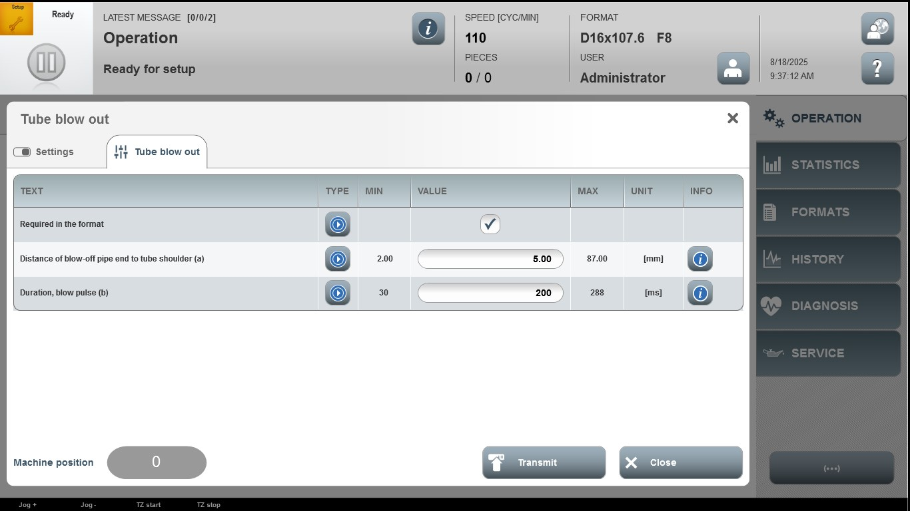

Acceptance criterion | Limits | Pass / Fail: Dev-No. | Date | Initials
Screen matches screenshot | N / A
Duration of blow-off pipe end to tube shoulder (a) | 2.00 …87.00
Duration, blow pulse (b) | 30 … 288

